# Difference Between **new operator** and **newInstance()** Method:

|  |  |  |
| --- | --- | --- |
| **Difference** | **new operator** | **newInstance()** |
| Object Creation | Test t=new Test() | Obtject obj=Class.forName(“className”).newInstance() |
| Argument Constructor() | Test t=new Test();  Test t=new Test(10,10);  If you use no-argument constructor compiler call no-argument constructor | .newInstance()  {  no-argument constructor() only  }  **We can’t pass parameterized contractor**  **If we pass parameter then we will get “InstantiationException”** |
| Exception Difference : If class is **not** there | Test t=new Test();  If Test class is not there then we will get “**NoClassDefFountExcption**”  Note: NoClassDefFoundException is the UncheckedException. | Obtject obj=Class.forName(“Test”).newInstance();  If Test class is not there then we will get  “**ClassNotFoundException**”  Note: ClassNotFoundExption is the Checked Exception. |

# Difference between **“==” & “.equals()”** method.

|  |  |  |
| --- | --- | --- |
| **Difference** | **Double equals operator(==)** | **equals() method** |
| Definition | Double equals operator(==) is for “**Reference Comparison**” | Equals method is for “**content comparison**” |
| Example | String s1=new String(“Rahul”);  String s2=new String(“Rahul”);  **System.out.println(s1==s2) - >False** | String s1=new String(“Rahul”);  String s2=new String(“Rahul”);  **System.out.println(s1.equals(s2))->True** |

# Difference between “**ClassNotFoundException**” & “**NoClassDefFoundError**”

|  |  |  |
| --- | --- | --- |
| **Difference** | **ClassNotFoundException** | **NoClassDefFoundError** |
| Definition | At the runtime if the corresponding .class file not there then we will get “**ClassNotFoundException**.  If we not set hardcoded class name. | At the runtime if **.class** file is not there to the corresponding .java file then we will get “**NoClassDefFoundError**”  If we hardcoded uses the class then only we well get this error. |
| Example | Object obj=Class.forName(“Test”).newInstance();  If at the runtime Test.class not then we will get this exception.  Note : For Dynamically provided hardcoded class name, at runtime .class file not there then we will get this exception. | Test t=new Test();  If at the runtime Test.class not then we will get this exception.  Note: For hardcoded class name at the runtime .class file not there then only we wil get this error. |
| Which exception | Checked Exceptions | Unchecked Exception |

# Difference between “**CheckedException**” & “**UncheckedException**”

|  |  |  |
| --- | --- | --- |
| **Difference** | **CheckedException** | **UncheckedException** |
| Definition | The exception which are checked by compiler for smooth execution of the program at runtime are called checkedexception.  Example :  HallticketMissingException  PenNotWorkingException  FileNotFoundException  In the case of checked exceptions compiler will check whether we are handling exception if the programmer not handling then we will get compile time error.  Public static void main(String[] arge){  PrintWriter pw=new PrintWriter(“abc.txt);  pw.write(“hello”);  }  Compiler will tell you :  Exception: Unreported exception java.io.FileNotFoundException; must be caught or declared to be thrown. | RuntimeException and it’s child classes, Error and it’s child classes are unchecked. Except this remaining are checked exceptions.  Example:  Arithmetic Exception  System.out.println(10/0); |
|  | Checked by compiler time | Checked by runtime |
| Extends | Exception | RuntimeException |
|  | Show recoverable condition | Show programming error |

# Difference between “**Exception**” & “**Error**”

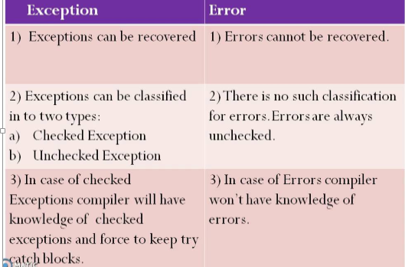

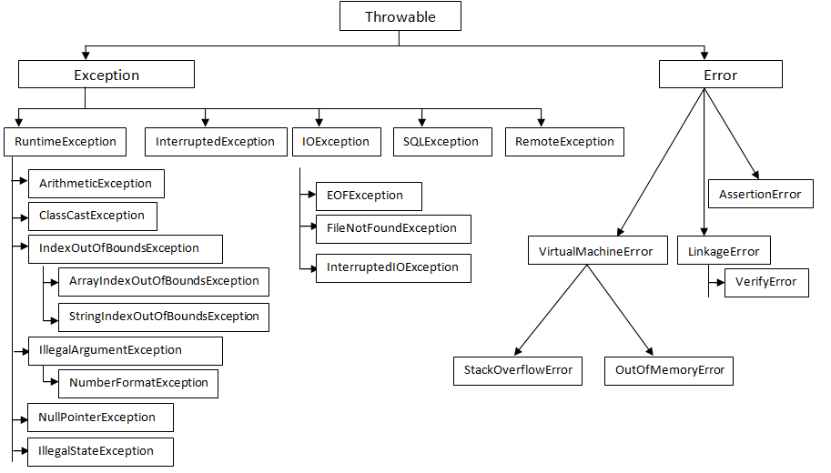

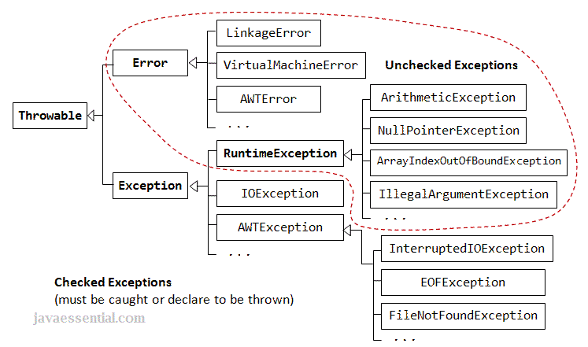

# What is fully checked exception and Partially checked exception:

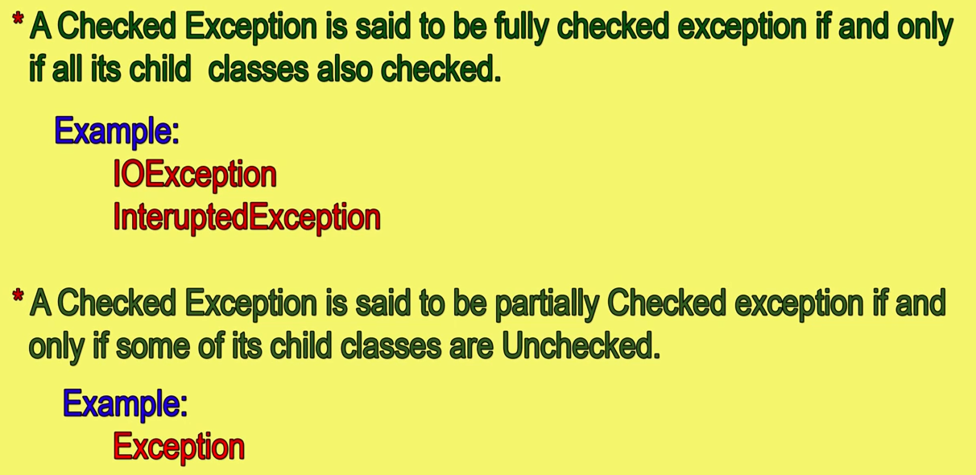



# final, finally & Finalize() :

## final-:

1. final is an modifier applicable for classes,methods and variables. If a class declare as final then we can not extends that class.i.e., we cannot create child class for that class.

2. If a method declare as a final then we cannot override that method in the child class.

3. If a variable declare as a final then it will become constant and can’t perform re-assignment for that variable.

## finally-:

finally is a block always associated with try catch to maintain “CleanUp” code.

## Finalize()-:

Finalize() is a method which is always invoked by “Garbage Collector” just before destroying an object to perform cleanup activities.

## Note:

* Finally meant for cleanup activities related to try block. Where as finalize() meant for cleanup activities related to object.

# Difference between “**Interface**” & “**Abstract Class**”

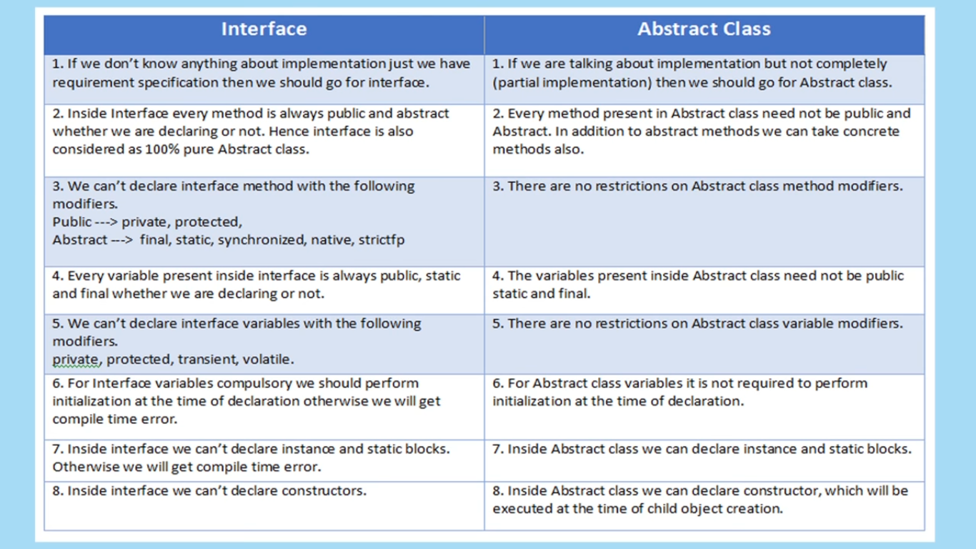

# Difference between “**Overloading**” & “**Overriding**”

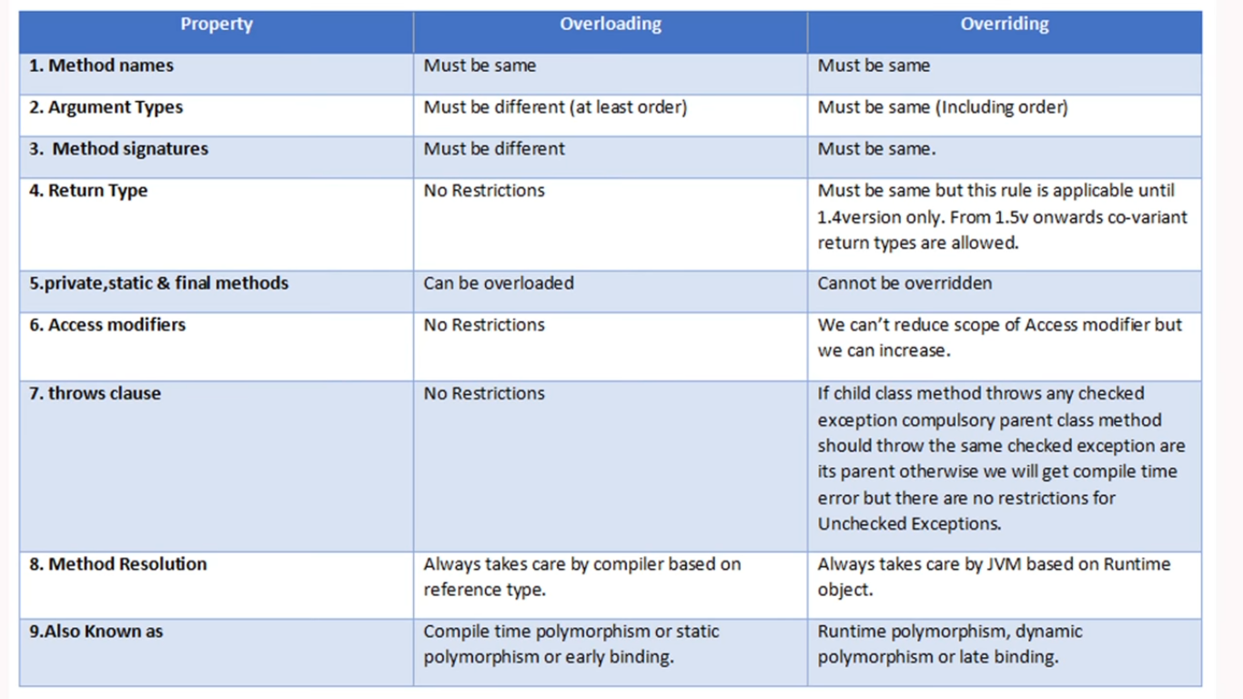

# Difference between “**StringBuffer**” & “**StringBuilder**”

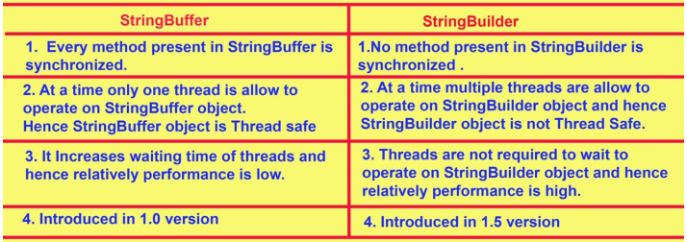

# Difference between “**String**” & “**StringBuffer**”

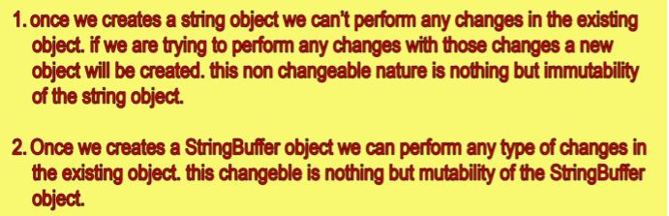

# Difference between “**throw**” & “**throws**”

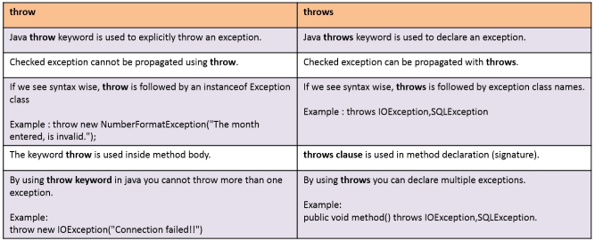

# **Traditional Collections**

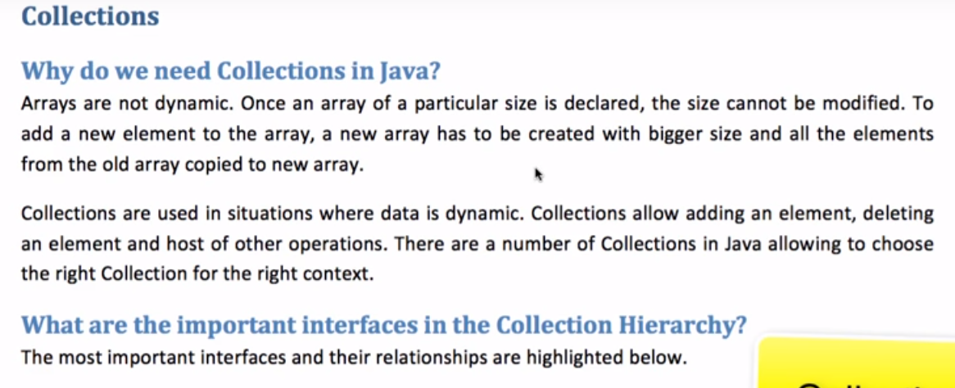

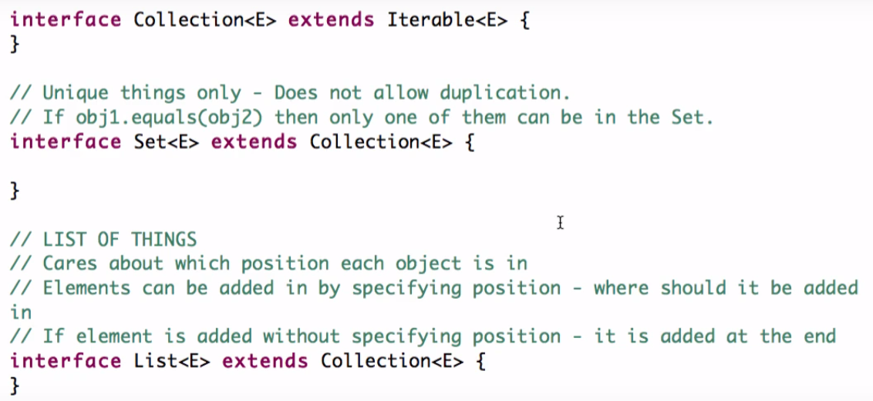

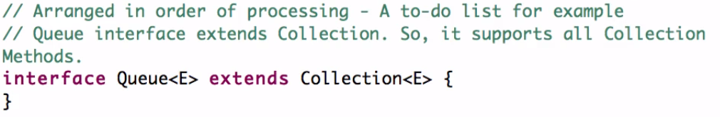

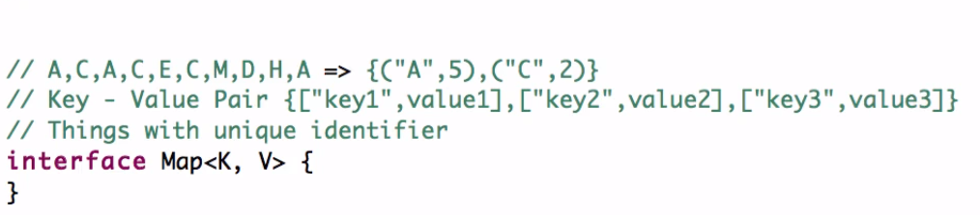

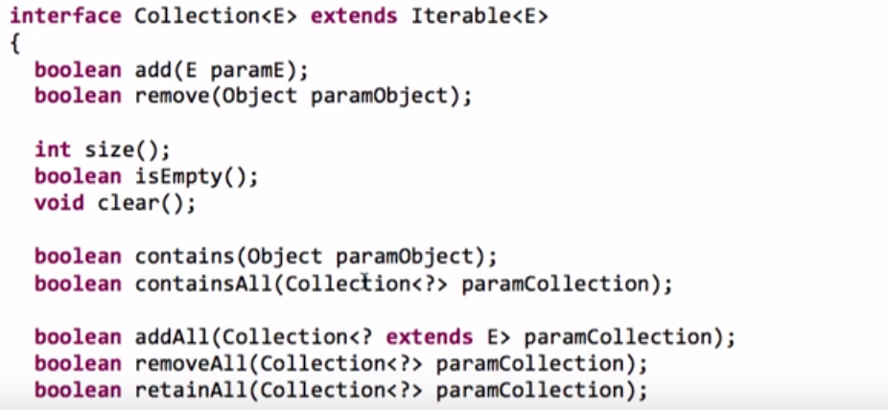

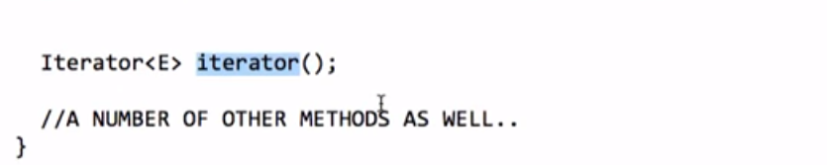

**public** **abstract** **interface** Iterable<T>

{

**public** **abstract** Iterator<T> iterator();

}

Note: In particular, c1.equals(c2)implies(kaa tatpary) that c1.hashCode()==c2.hashCode().

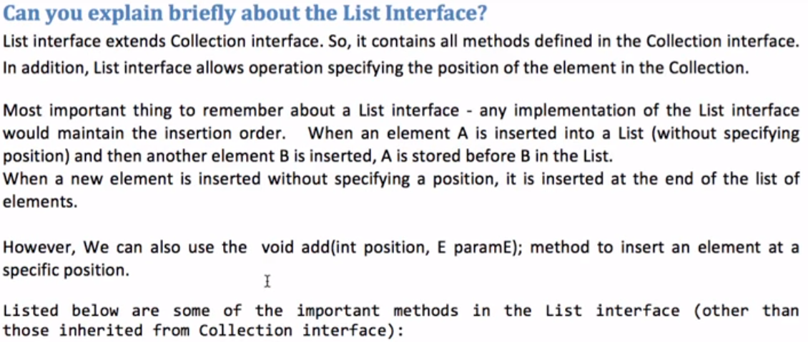

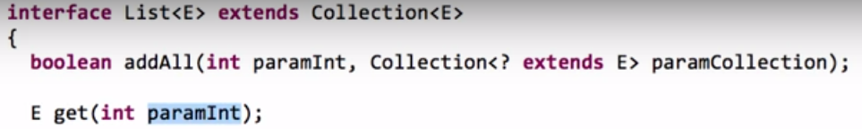

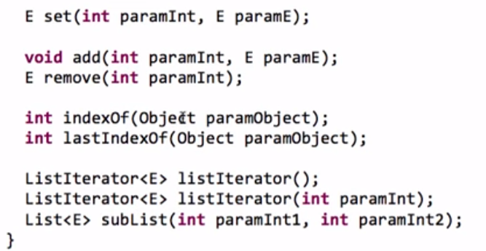

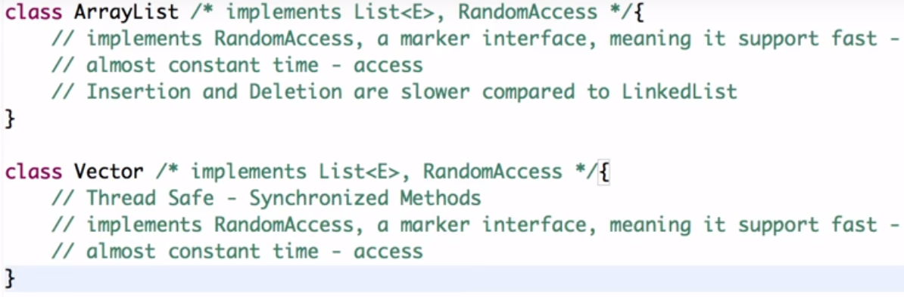

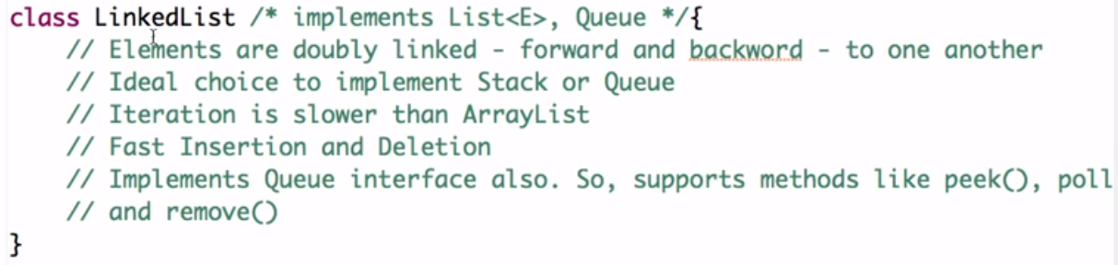

## Set Interface:-

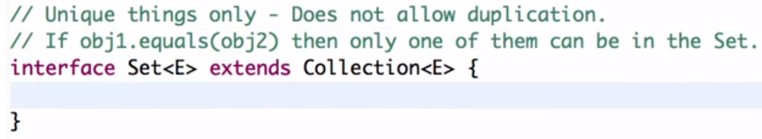

SortedsSet interface maintains order but Set interface does not maintains ordering.

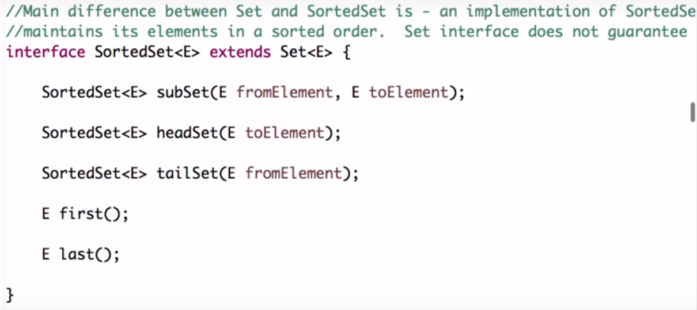

Navigate closest matches for a give search targets.

.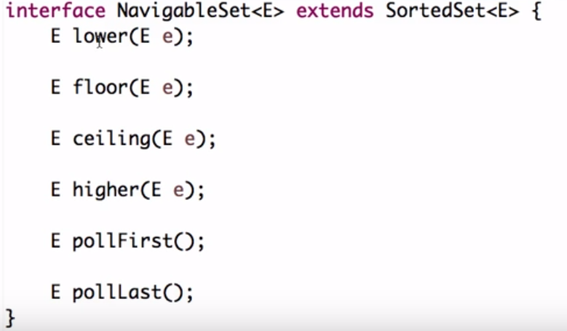

**HashSet**  is implementation of **Set** Interface which does not allow duplicate value all the methods which are in **Collection** **Framework** are also in Set Interface by default but when we are talking about Hash set the main thing is **objects which are going to be stored in HashSet must** [**override HYPERLINK "http://javarevisited.blogspot.com/2011/02/how-to-write-equals-method-in-java.html"equalsHYPERLINK "http://javarevisited.blogspot.com/2011/02/how-to-write-equals-method-in-java.html"()**](http://javarevisited.blogspot.com/2011/02/how-to-write-equals-method-in-java.html) **and hashCode() method** so that we can check for equality and no duplicate value are stored in our set.if we have created our own objects we need to implement **hashCode**() and **equal**() in such a manner that will be able to compare objects correctly when storing in a set so that duplicate objects are not stored,if we have not override this method objects will take default implementation of this method.

**public boolean add(Object o)**Method is used to add element in a set which returns false if it’s a duplicate value in case of  HashSet otherwise returns true if added successfully.

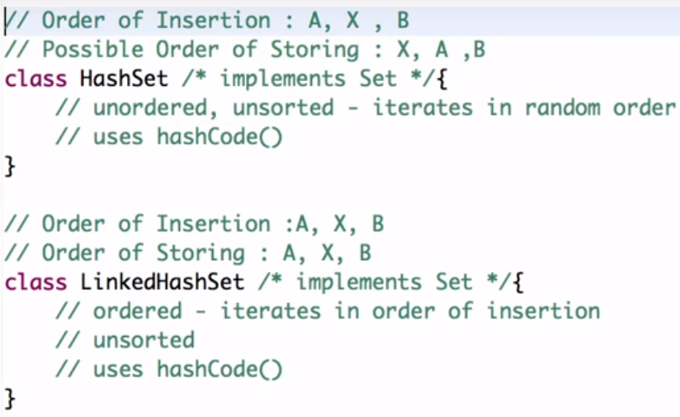

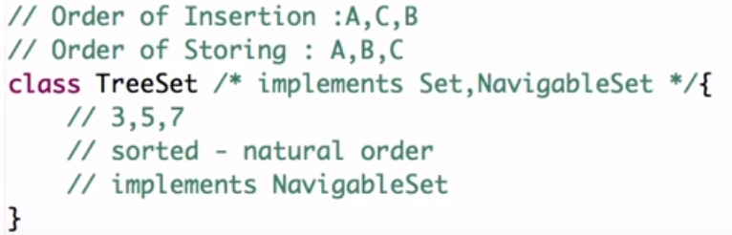

Queue Interface:-

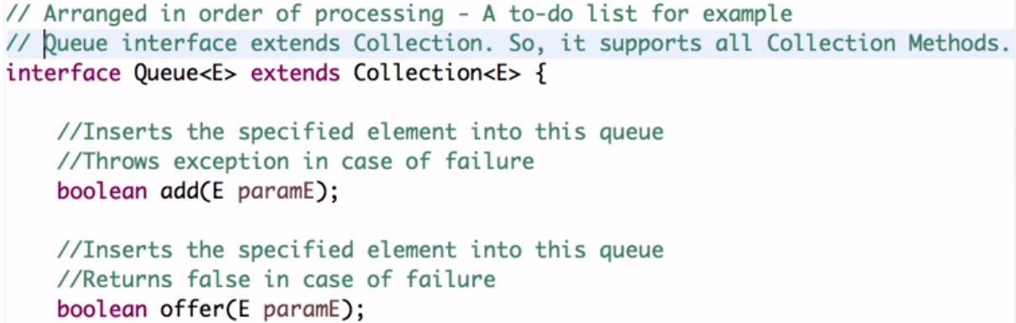

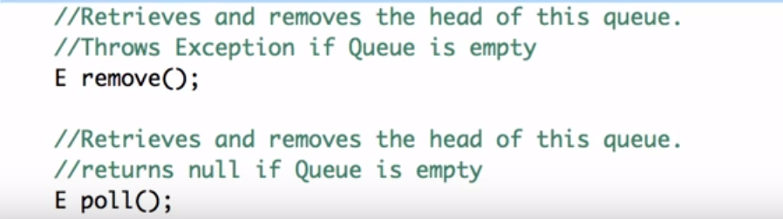

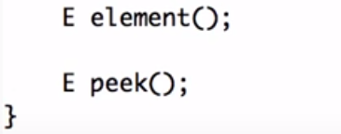

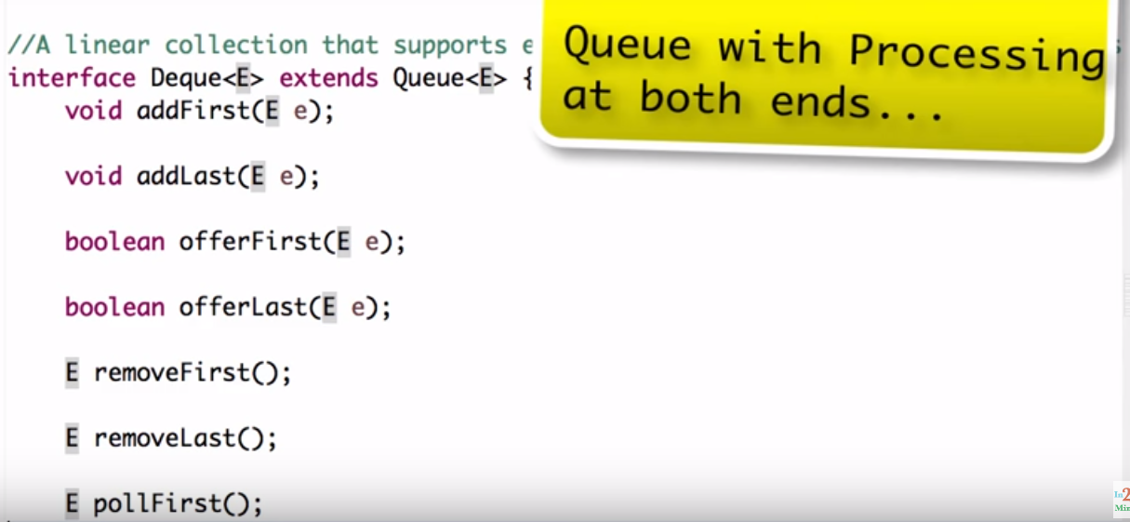

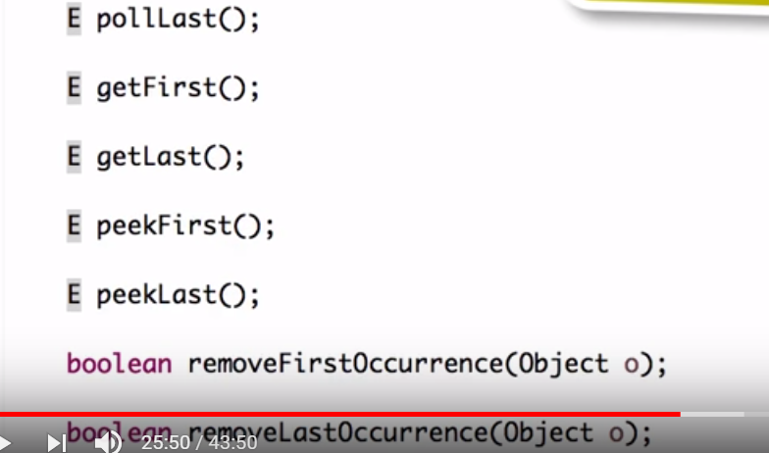

BlockingQueue Interface:-

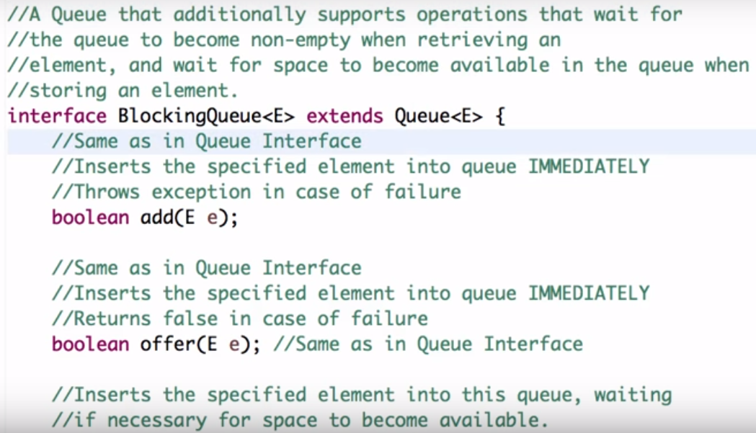

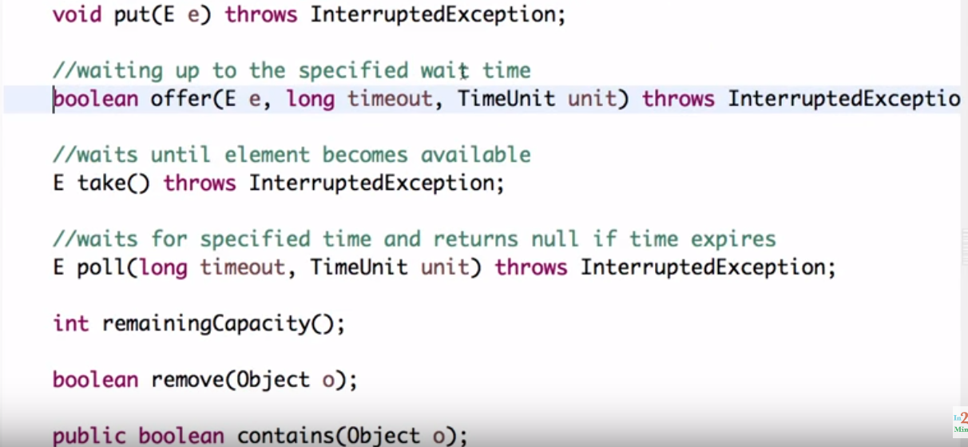

Classes of queue interface:-

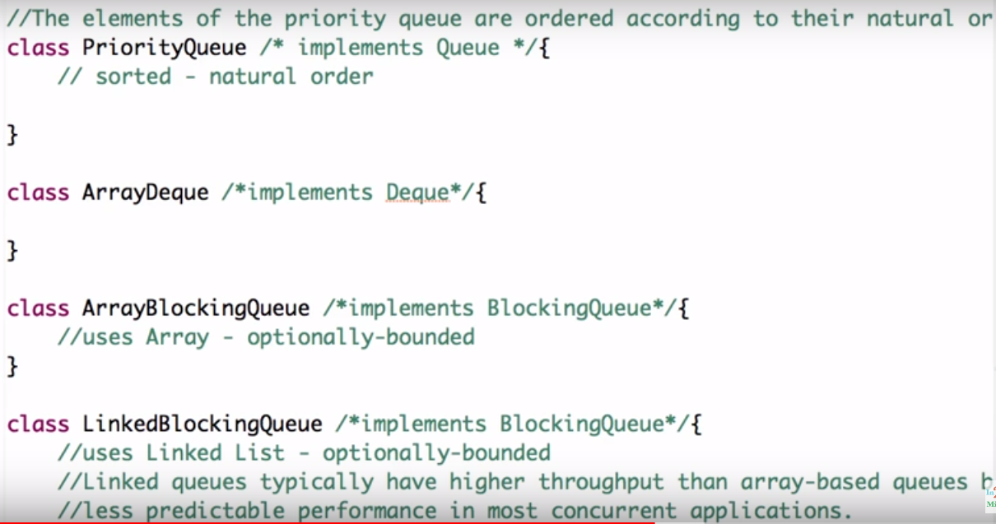

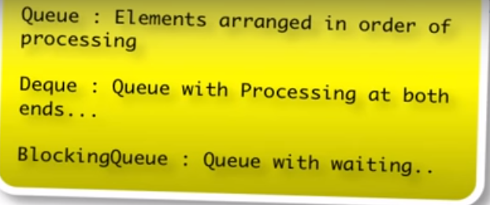

## Map Interface:

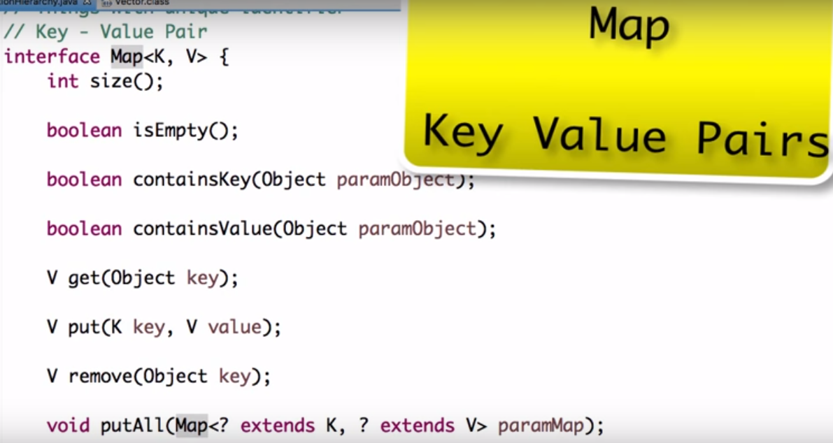

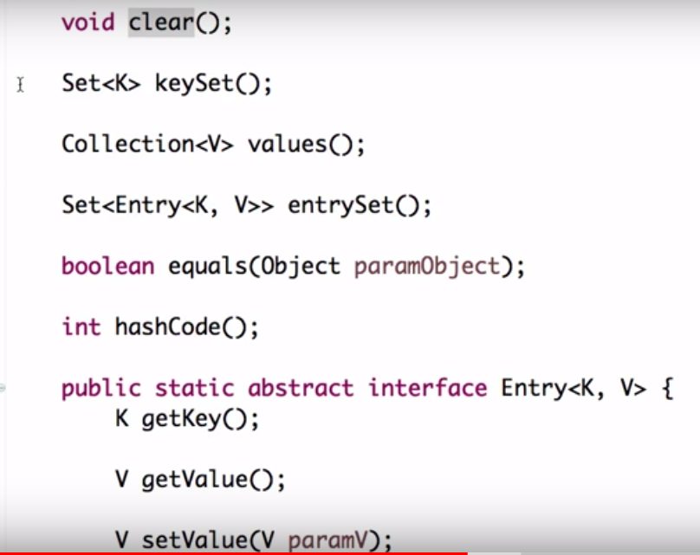

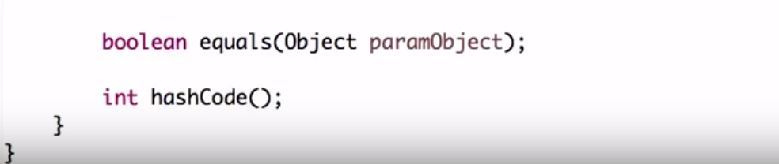

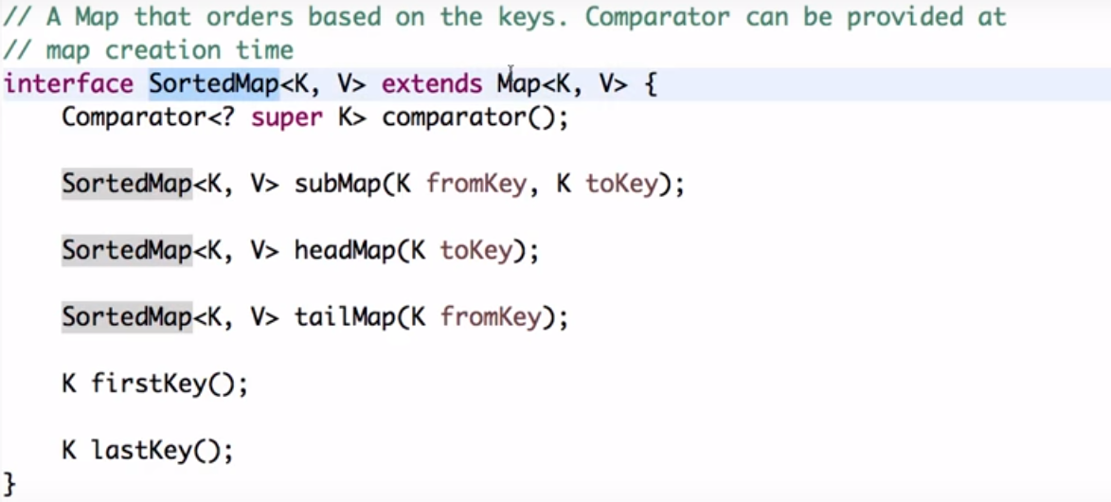

Navigate closest matches for a give search targets.

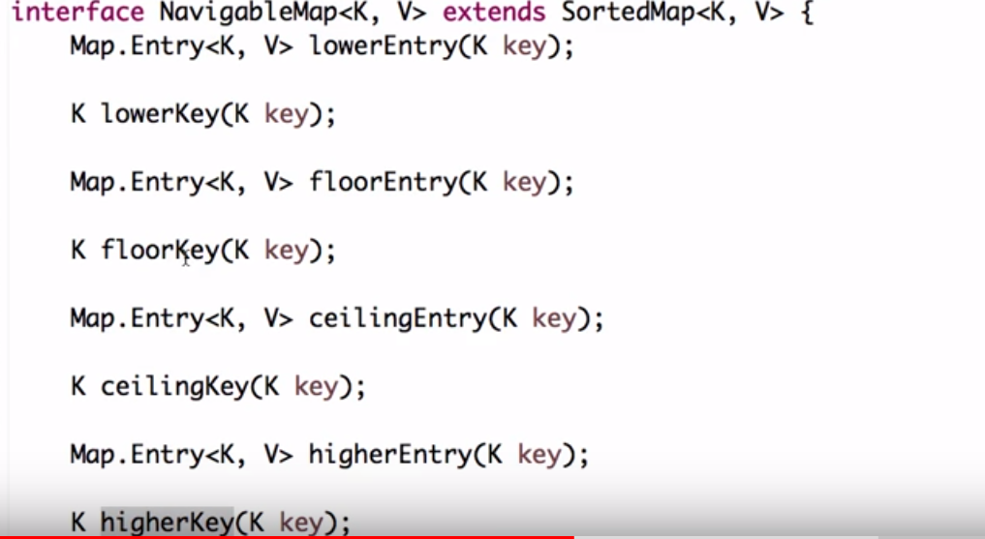

Classes for Map Interface:-

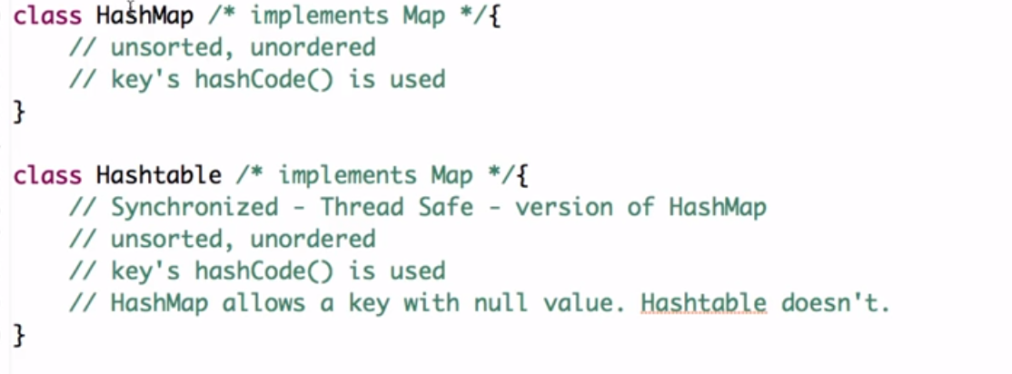

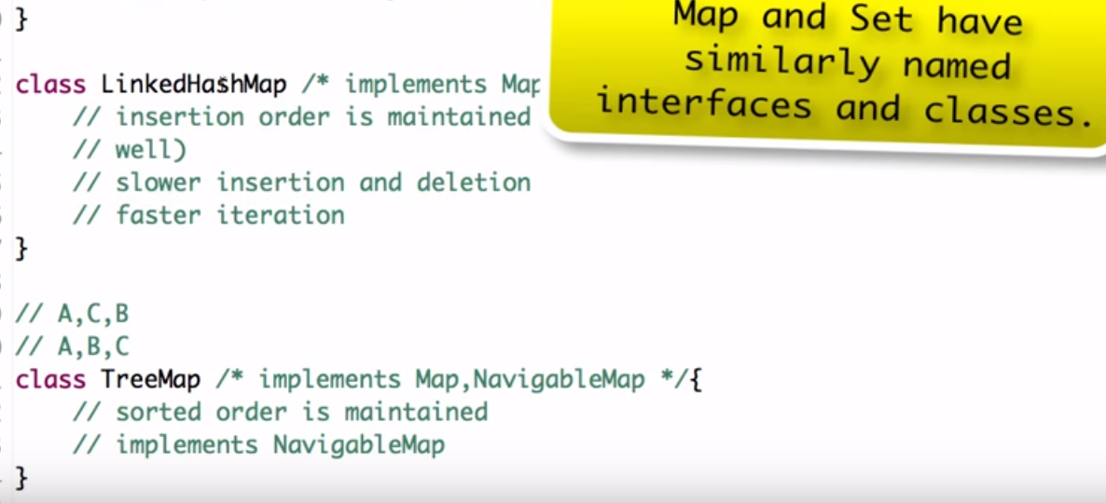

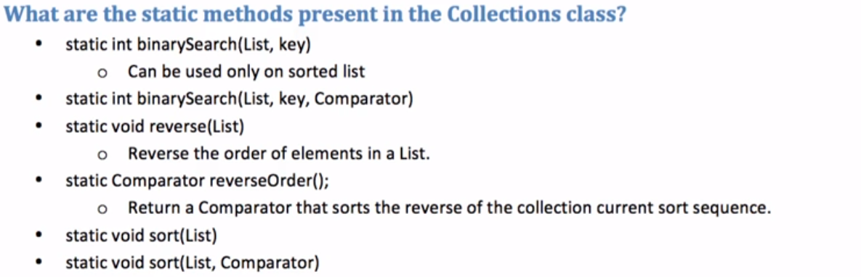

# **Comparable & Comparator Interfaces**

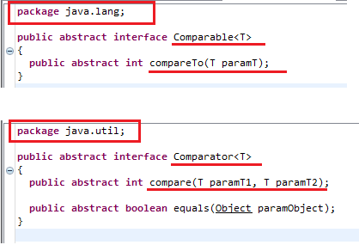

## Comparable Interface Example:

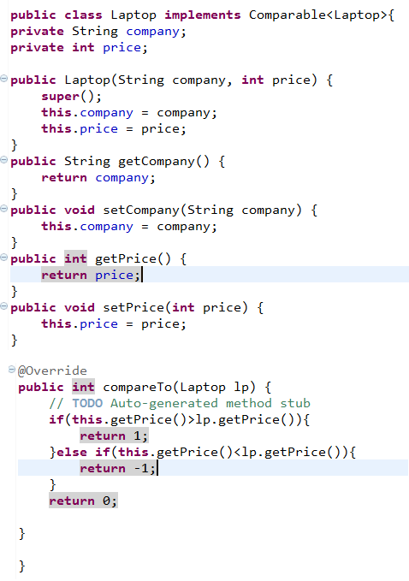

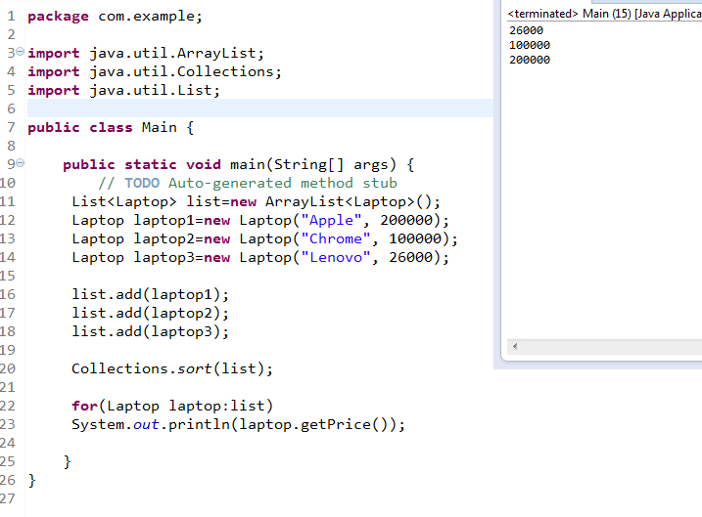

## Comparator Interface Example:

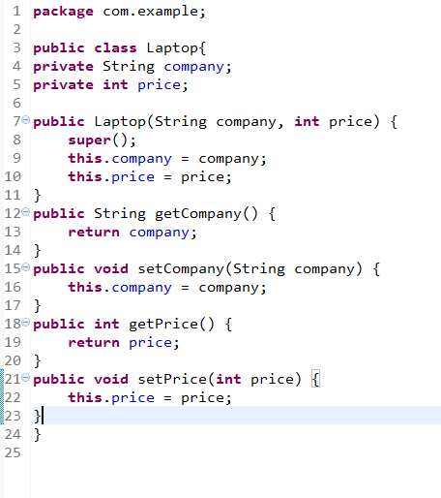

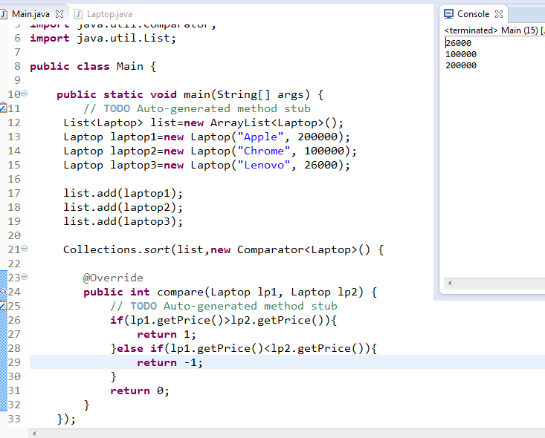

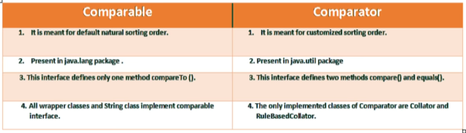

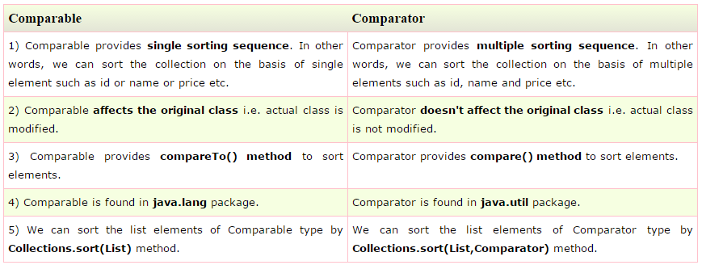

# Map Interface:

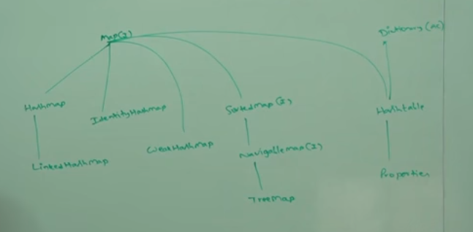

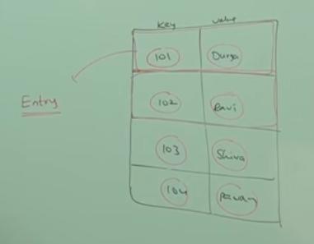

### Map.Put() Method and return type:

The return type for the put() method is object type.

If we add (map.put(101,’rahul’)) then it will return previous value corresponding to the key(101).

Ex. If we are adding first time then it will return object with null value, but if second time we are adding (map.put(101,’BHATI’)) then it will return object with “rahul” value.

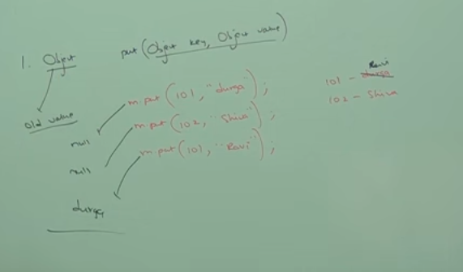

Note:Collections Views Methods are below :

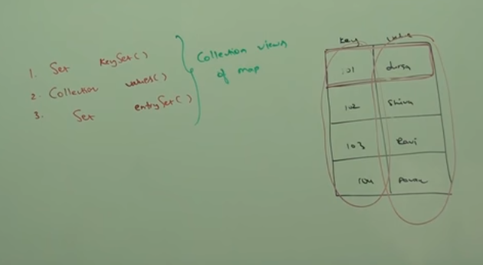

# **How hash map internally work?**

In Hashmap collection class we are having put(key,value) and get(key) methods

By calling put(key,value) method, hasmap implementions calls hascode() method on key to get hashcode value ,which will get passed as an input to hashing function to get the bucket location to store the k-v pair in Map.Entry<K,V> in bucket.

Then at the time calling get(key) method ,even if 2 diffrents objects having same hashcode will get

fetched correctly by calling keys .equals() method to get the correct K,V pair to avoid collision.

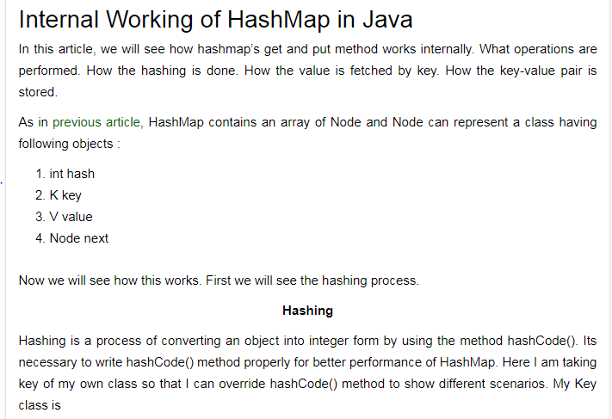

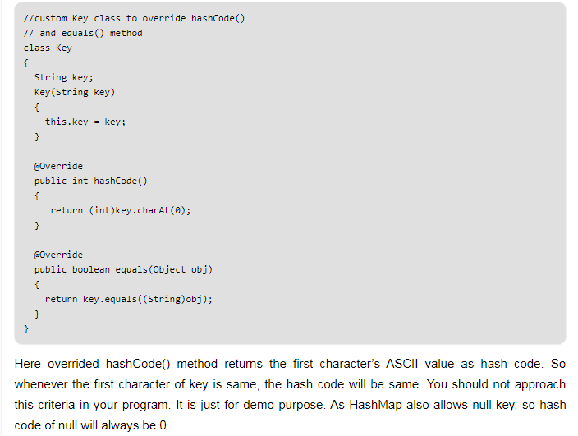

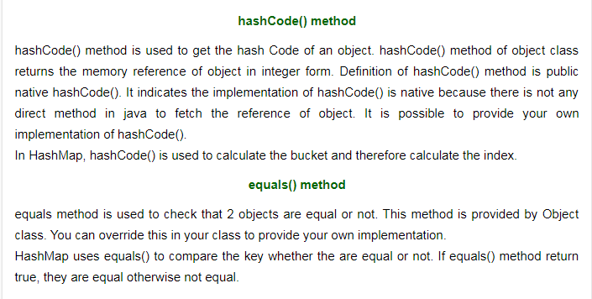

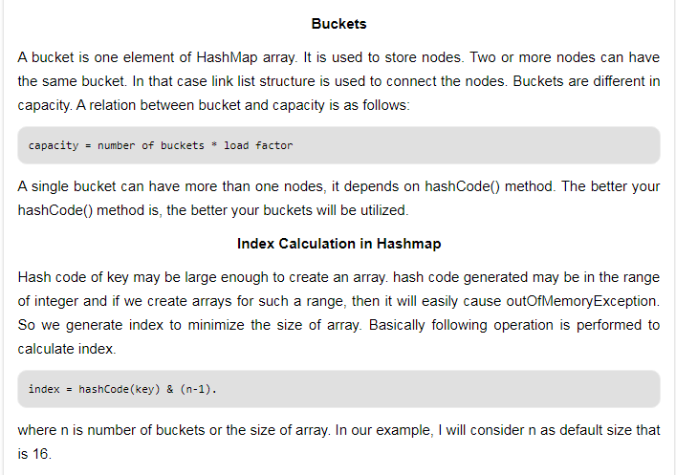

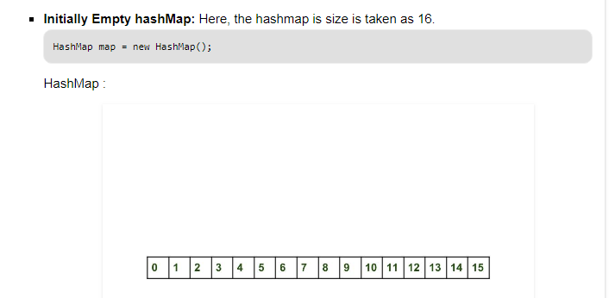

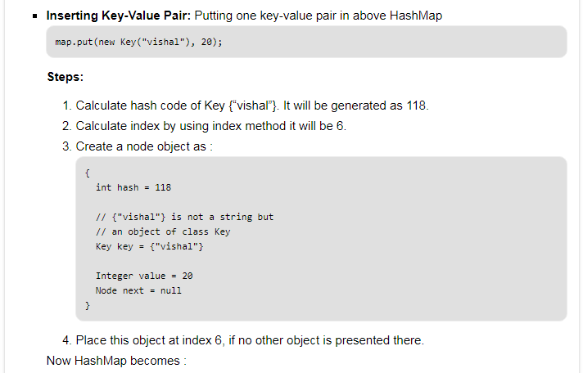

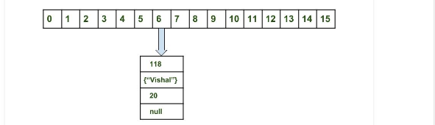

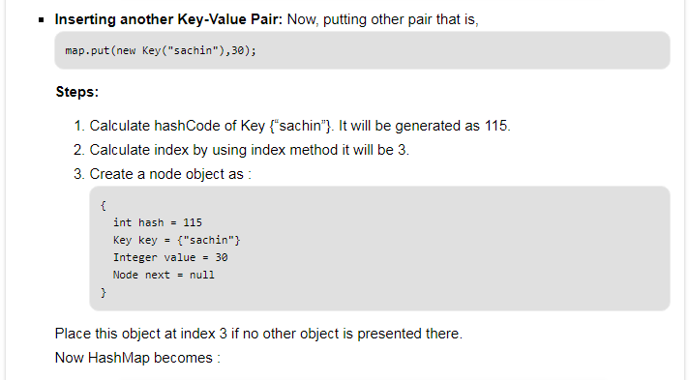



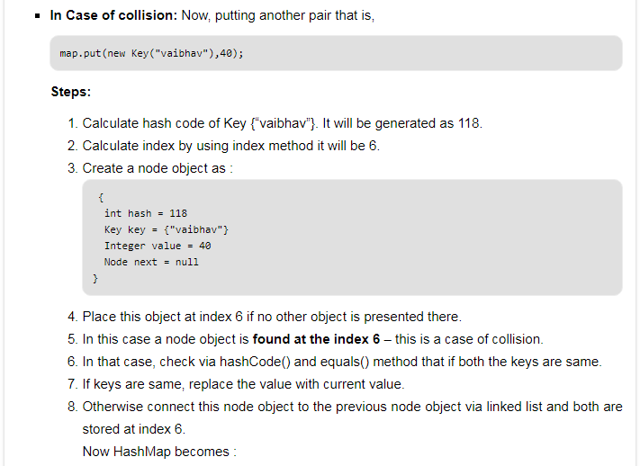

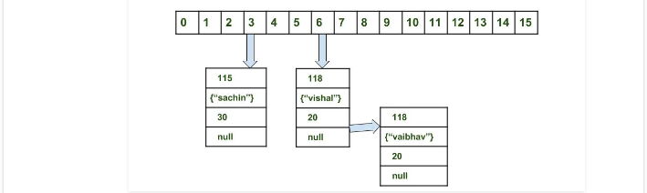

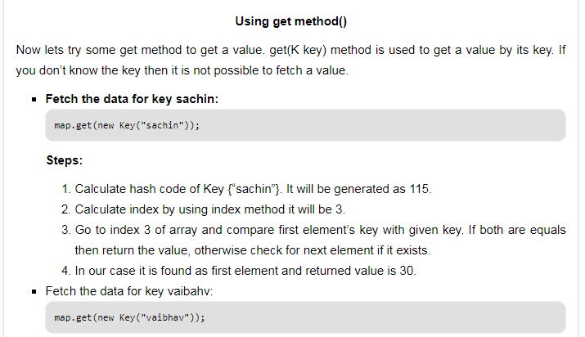

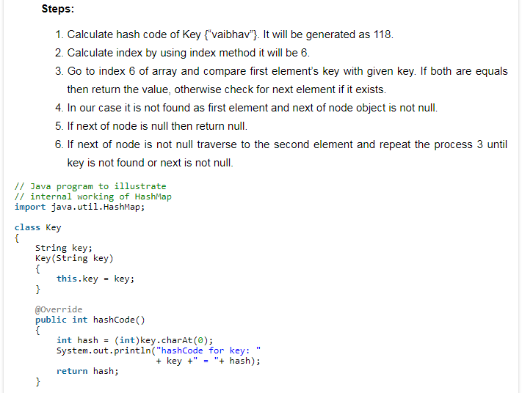

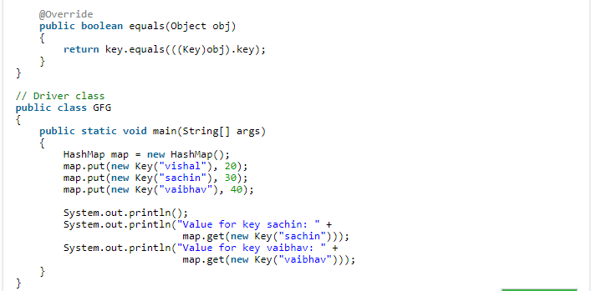

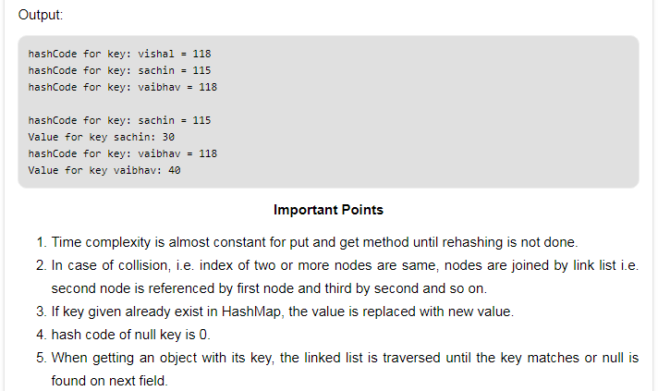

# **Initial Capacity Of HashMap:**

The capacity of an HashMap is the number of buckets in the hash table. The default initial capacity of the HashMap is 24 i.e 16. The capacity of the HashMap is doubled each time it reaches the threshold. i.e the capacity is increased to 25=32, 26=64, 27=128….. **when the threshold is reached.**

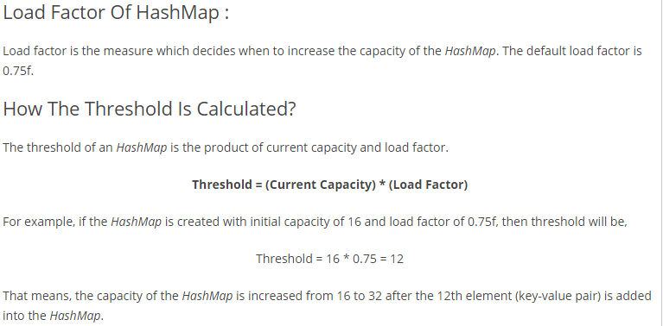

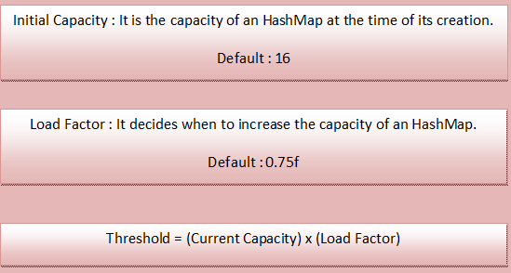

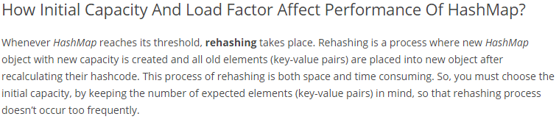

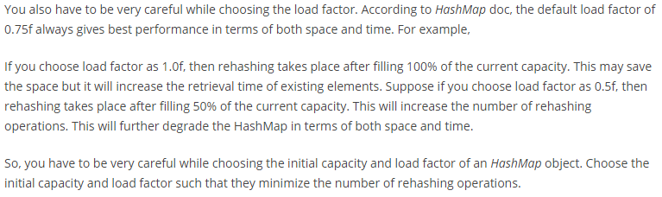

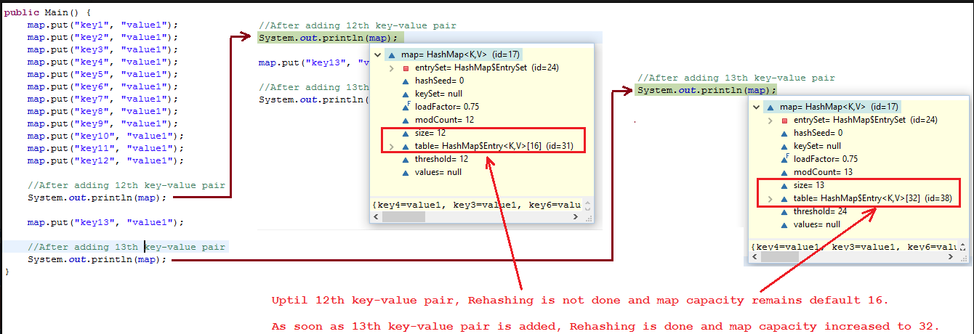

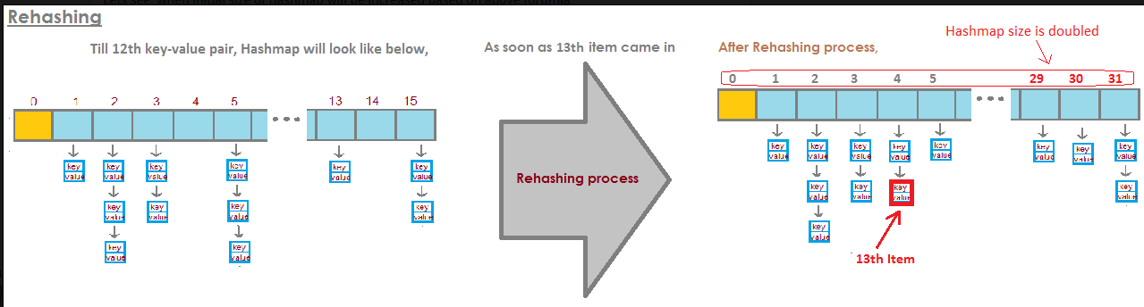

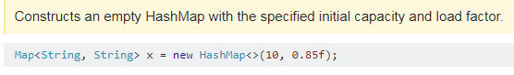

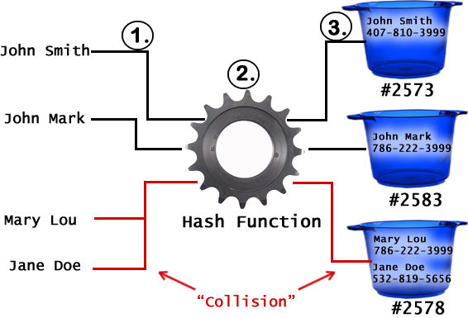

HashMap work on Hashing Principle.

HashMap.Java

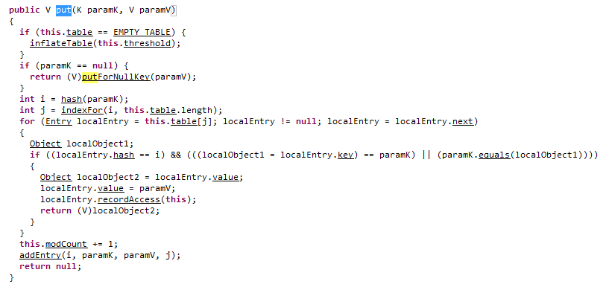

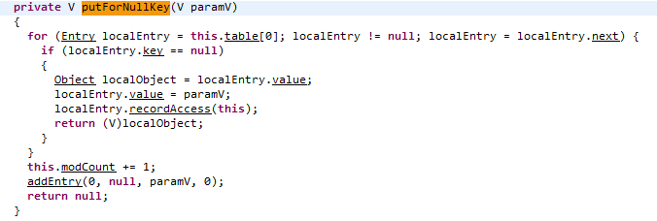

**addEntry(hashcode,key,value,bucket_position)**

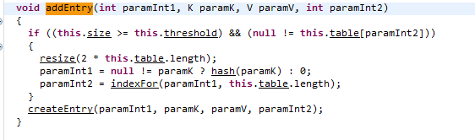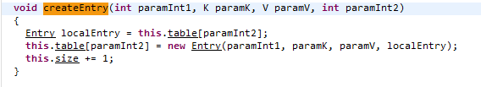

Example:

**Lets override default implemenation of hashcode() and equals():**

You don't have to always override these methods, but lets say you want to define equality of country object based on name, then you need to override equals method and if you are overriding equals method, you should override hashcode method too. Below example will make it clear.

Lets see with the help of example.We have a class called Country

**1. Country.java**

[view plainprint?](http://www.java2blog.com/2014/02/hashcode-and-equals-method-in-java.html)

1. **package** org.arpit.java2blog;
3. **public** **class** Country {
5. String name;
6. **long** population;
7. **public** String getName() {
8. **return** name;
9. }
10. **public** **void** setName(String name) {
11. **this**.name = name;
12. }
13. **public** **long** getPopulation() {
14. **return** population;
15. }
16. **public** **void** setPopulation(**long** population) {
17. **this**.population = population;
18. }
20. }

This country class have two basic attributes- name and population.

Now create a class called "EqualityCheckMain.java"

[view plainprint?](http://www.java2blog.com/2014/02/hashcode-and-equals-method-in-java.html)

1. **package** org.arpit.java2blog;
3. **public** **class** EqualityCheckMain {
5. /**
6. * @author arpit mandliya
7. */
8. **public** **static** **void** main(String[] args) {
10. Country india1=**new** Country();
11. india1.setName("India");
12. Country india2=**new** Country();
13. india2.setName("India");
14. System.out.println("Is india1 is equal to india2:" +india1.equals(india2));
15. }
17. }

When you run above program, you will get following output

[view plainprint?](http://www.java2blog.com/2014/02/hashcode-and-equals-method-in-java.html)

1. Is india1 is equal to india2:**false**

In above program, we have created two different objects and set their name attribute to "india".

Because both references india1 and india2 are pointing to different object, as default implementation of equals check for ==,equals method is returning false. In real life, it should have return true because no two countries can have same name.

Now lets override equals and return true if two country's name are same.

Add this method to above country class:

[view plainprint?](http://www.java2blog.com/2014/02/hashcode-and-equals-method-in-java.html)

1. @Override
2. **public** **boolean** equals(Object obj) {
3. **if** (**this** == obj)
4. **return** **true**;
5. **if** (obj == **null**)
6. **return** **false**;
7. **if** (getClass() != obj.getClass())
8. **return** **false**;
9. Country other = (Country) obj;
10. **if** (name == **null**) {
11. **if** (other.name != **null**)
12. **return** **false**;
13. } **else** **if** (!name.equals(other.name))
14. **return** **false**;
15. **return** **true**;
16. }

and now run EqualityCheckMain.java again

You will get following output:

[view plainprint?](http://www.java2blog.com/2014/02/hashcode-and-equals-method-in-java.html)

1. Is india1 is equal to india2:**true**

Now this is because overriden equals method return true if two country have same name.  
One thing to remember here, signature of equals method should be same as above.

**Lets put this Country objects in hashmap:**

Here we are going to use Country class object as key and its capital name(string) as value in HashMap.

[view plainprint?](http://www.java2blog.com/2014/02/hashcode-and-equals-method-in-java.html)

1. **package** org.arpit.java2blog;
3. **import** java.util.HashMap;
4. **import** java.util.Iterator;
6. **public** **class** HashMapEqualityCheckMain {
8. /**
9. 3     * @author Arpit Mandliya
10. */
11. **public** **static** **void** main(String[] args) {
12. HashMap<Country,String> countryCapitalMap=**new** HashMap<Country,String>();
13. Country india1=**new** Country();
14. india1.setName("India");
15. Country india2=**new** Country();
16. india2.setName("India");
18. countryCapitalMap.put(india1, "Delhi");
19. countryCapitalMap.put(india2, "Delhi");
21. Iterator<Country> countryCapitalIter=countryCapitalMap.keySet().iterator();
22. **while**(countryCapitalIter.hasNext())
23. {
24. Country countryObj=countryCapitalIter.next();
25. String capital=countryCapitalMap.get(countryObj);
26. System.out.println("Capital of "+ countryObj.getName()+"----"+capital);
28. }
29. }
30. }

When you run above program, you will see following output:

1. Capital of India----Delhi
2. Capital of India----Delhi

Now you must be wondering even through two objects are equal why HashMap contains two key value pair instead of one.This is because First HashMap uses hashcode to find bucket for that key object, if hashcodes are same then only it checks for equals method and because hashcode for above two country objects uses default hashcode method,Both will have different memory address hence different hashcode.

Now lets override hashcode method.Add following method to Country class

[view plainprint?](http://www.java2blog.com/2014/02/hashcode-and-equals-method-in-java.html)

1. @Override
2. **public** **int** hashCode() {
3. **final** **int** prime = 31;
4. **int** result = 1;
5. result = prime * result + ((name == **null**) ? 0 : name.hashCode());
6. **return** result;
7. }

Now run HashMapEqualityCheckMain.java again

You will see following output:

1. Capital of India----Delhi

So now hashcode for above two objects india1 and india2 are same, so Both will be point to same bucket,now equals method will be used to compare them which  will return true.  
This is the reason java doc says "if you override equals() method then you must override hashCode() method"

# **What happened if hascode() returning same has code(means returning 1):**

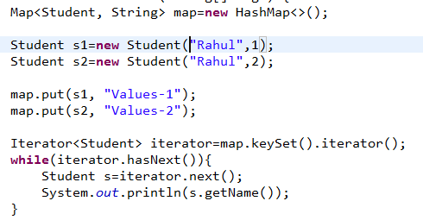

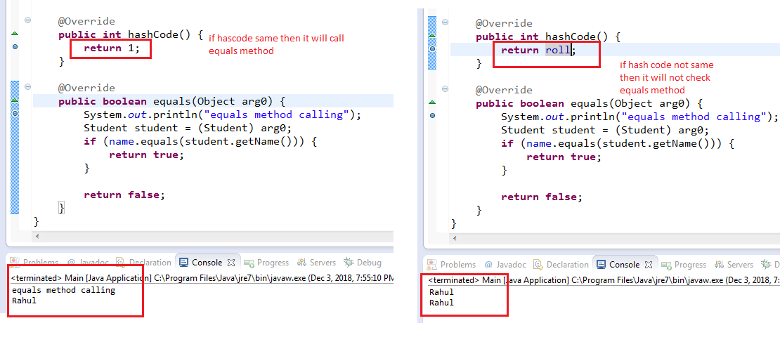

# Concurrent Collections

## Difference between “**Traditional**” & “**Concurrent**” Collections

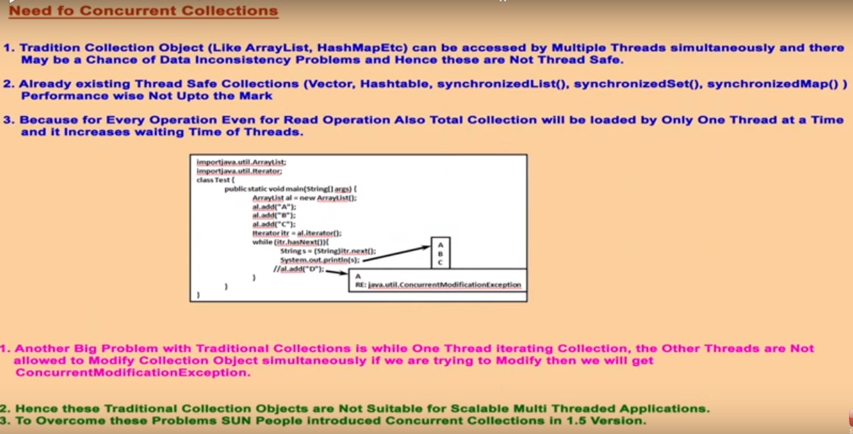

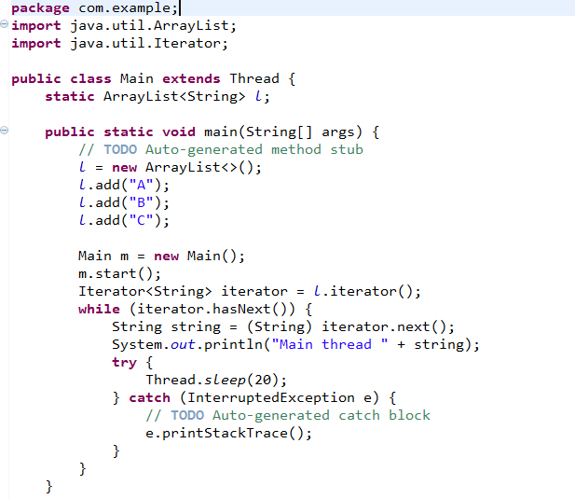

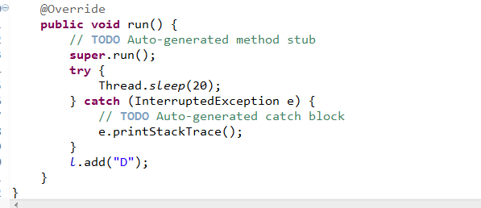

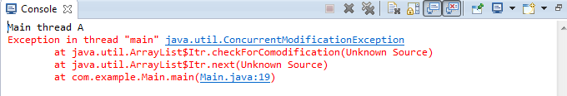

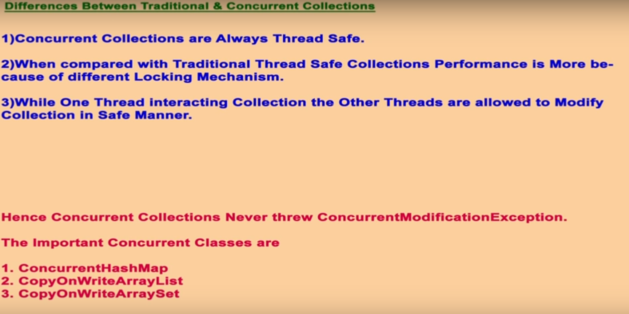

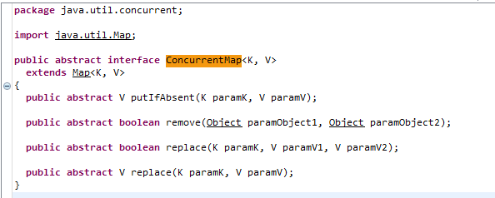

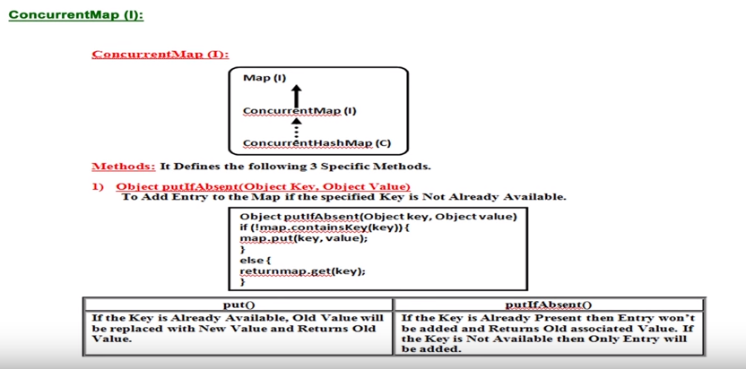

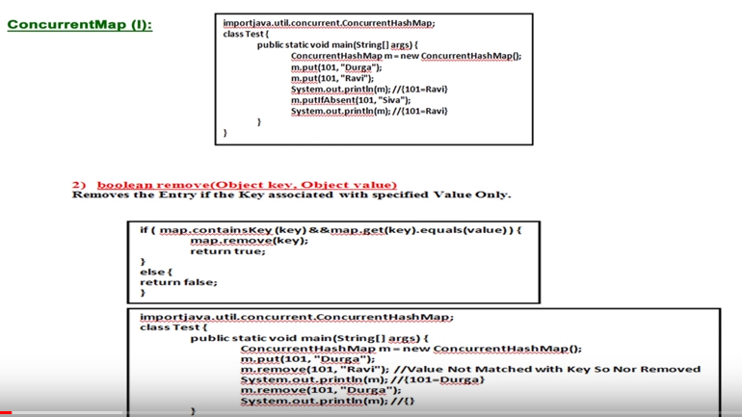

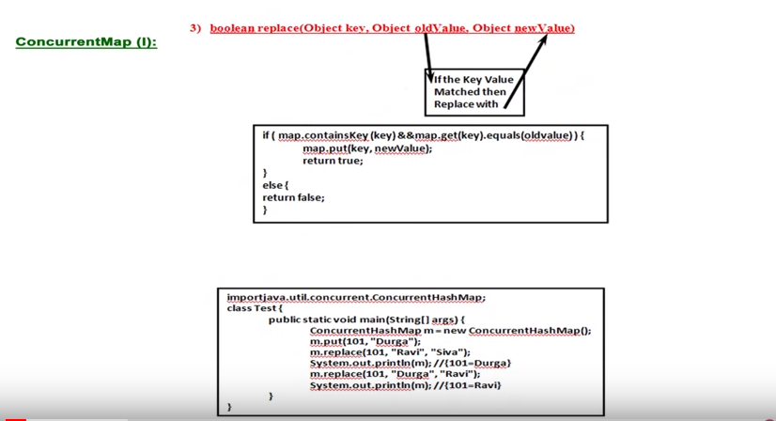

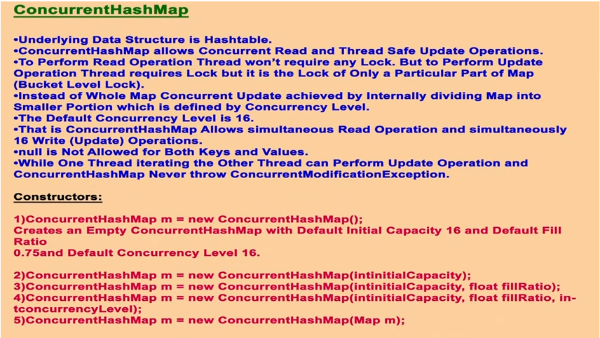

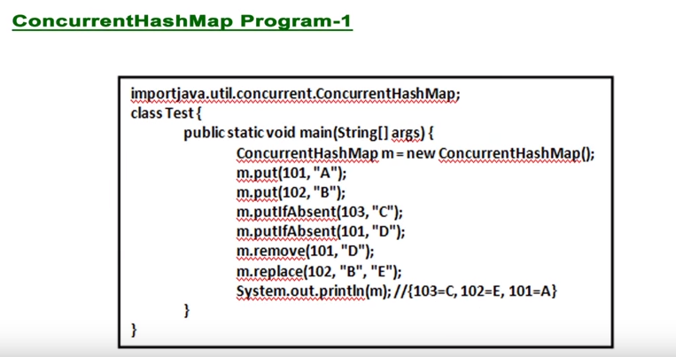

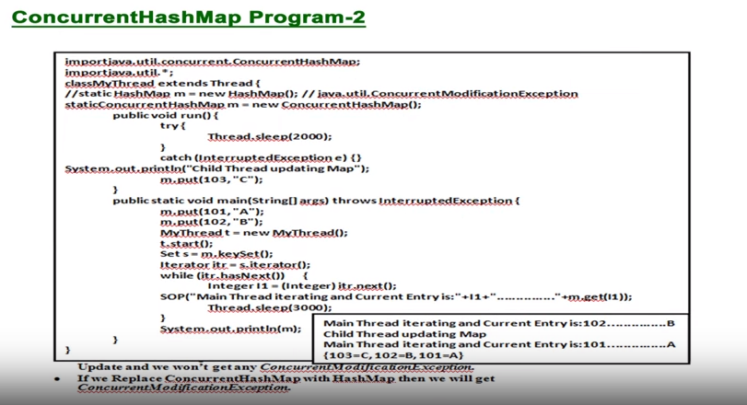

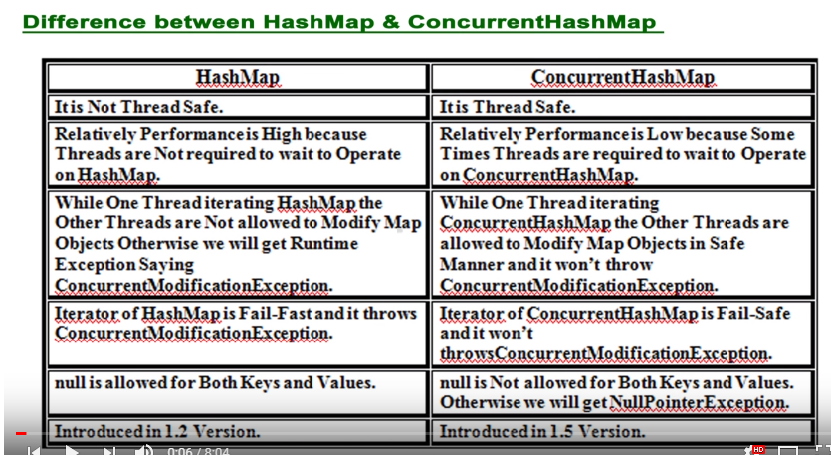

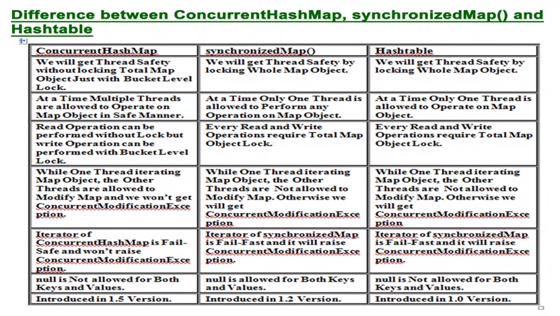

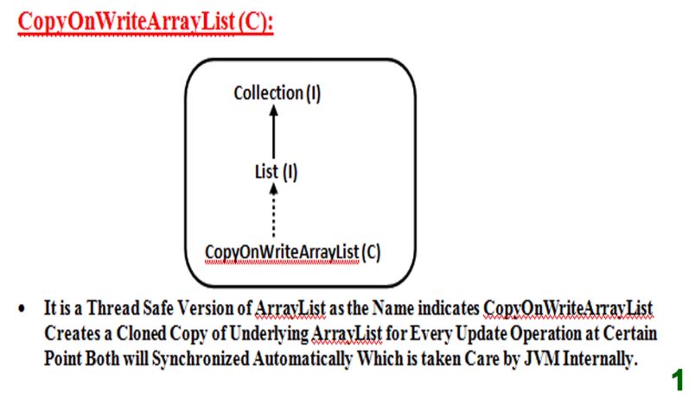 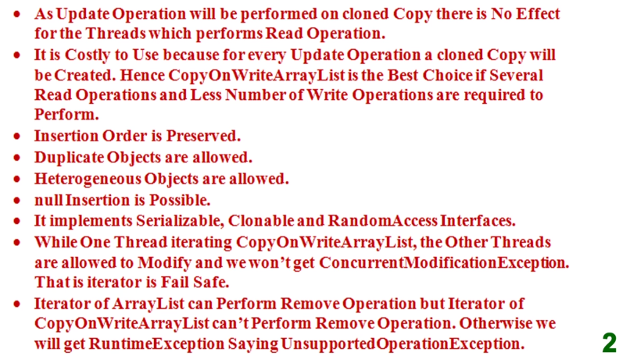

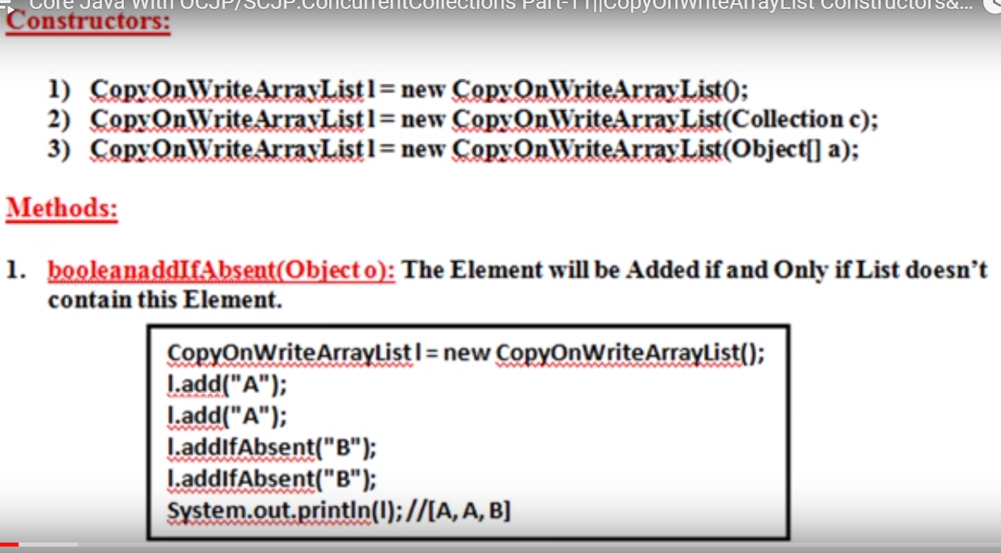

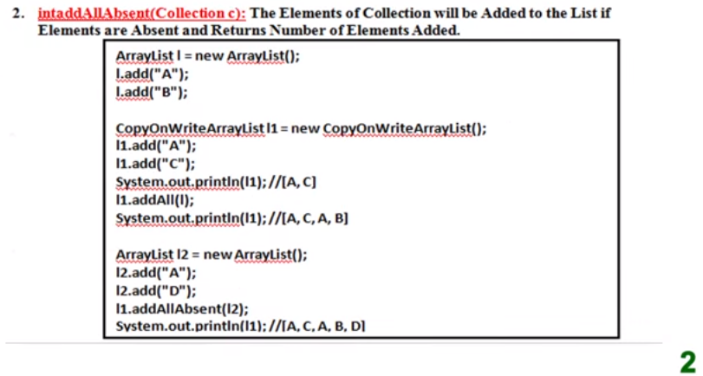

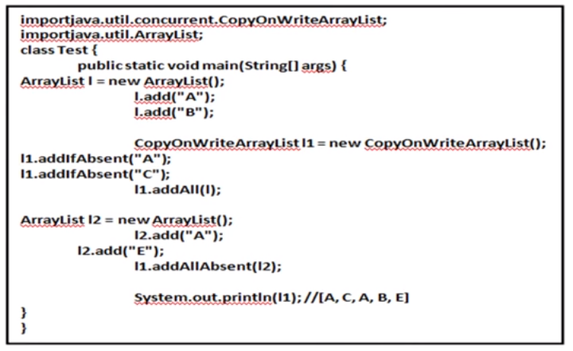

Note: In above example l1.addAll(l)----------is the normal arraylist method that’s why it will not check already added elements. Means it will directly addAll elements of the “l” into “l1” object.

